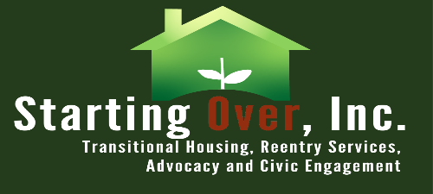

Starting Over, Inc.
6355 Riverside Ave., Riverside CA 92506
www.startingoverinc.org

JOB TITLE
Peer Support Specialist
$19.00 hr. -21.00 hr.

Job Summary:
The Peer Support Specialist serves as a valuable resource and advocate for individuals facing various challenges, such as mental health issues, substance abuse, or other life transitions. Working from a place of personal experience and recovery, the Peer Support Specialist provides guidance, encouragement, and support to clients, empowering them to navigate their own paths to wellness and resilience.

General Duties:
Collaborate with clients to develop personalized support plans that focus on their strengths, goals, and desired outcomes. Assist in identifying resources and services, developing coping strategies, and setting achievable milestones. Regularly review and adjust support plans based on client progress and changing needs. Offer emotional support and encouragement to clients, providing them with a safe and supportive space to express themselves. Assist clients in developing practical life skills, such as problem-solving, decision-making, and effective communication. Help clients navigate and access community resources and services. Assist clients in developing practical life skills, such as problem-solving, decision-making, and effective communication. Identify and respond to clients experiencing crisis situations, such as suicidal ideation or emotional distress. Provide immediate support and, when necessary, facilitate access to appropriate crisis intervention services. Refer clients to additional professional services and community resources as needed. Maintain accurate and confidential client records, documenting interactions, progress, and outcomes. Adhere to organizational policies and procedures regarding documentation, data collection, and reporting requirements. Stay informed about best practices and emerging trends in peer support and mental health recovery.

Job Qualifications:
Personal lived experience with mental health challenges, substance abuse recovery, or related life experiences. Empathy, compassion, and the ability to establish rapport with diverse individuals. Knowledge of recovery-oriented principles and practices. Ability to maintain professional boundaries and confidentiality. Resilience and self-care practices to manage personal triggers and stress. Adherence to ethical guidelines and professional codes of conduct for peer support specialists.

Skills:
Effective verbal and written communication skills.
Competent with Microsoft Office, Gmail suite, and data entry.
Strong leadership and team management skills.
Analytical thinking and problem-solving skills.
Strong interpersonal and active listening skills.

