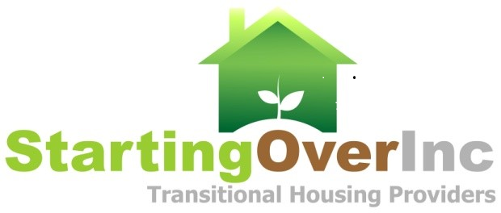

CULTIVATION
2022 Starting Over, Inc. Luncheon &
Barbara Barker Award Celebration
Corona Circle City Center
FRIDAY December 9, 2022 11:30 AM – 1:30 PM
Please Return Sponsorship Form No Later Than November 12, 2022. You may request to be invoiced.
PURCHASE FORM
X | SPONSORSHIP**  See the SPONSORSHIP, PROGRAM, SEATING BENEFITS & PRICING TABLE for Sponsorship Details.
 | DIAMOND (limited to 1 sponsor) |  |  |  |  |  | $10,000
 | PLATINUM (limited to 2 sponsors) |  |  |  |  |  | $7,500
 | GOLD (limited to 5 sponsors) |  |  |  |  |  | $5,000
 | SILVER |  |  |  |  |  | $2,500
 | BRONZE |  |  |  |  |  | $1,000
X | SPECIAL EDITION PROGRAM ADS**
 | FULL PAGE |  |  |  |  |  | $1,000
 | HALF PAGE |  |  |  |  |  | $500
 | QUARTER PAGE |  |  |  |  |  | $250
 | BUSINESS CARD |  |  |  |  |  | $100
SEATING**
TABLE(S) (8 Seats) |  |  | $480 |  | No. of Tables |  |  |  |  | Total $
SEAT(S) |  |  | $60 |  | No. of Seats |  |  |  |  | Total $
DONATED SEAT(S)
IMPORTANT Please email names of attendees to office@startingoverinc.org by December 1, 2022. We encourage the purchase and donation of seats for youth and seniors. Please indicate above the number of purchased seats you would like to donate.
DONATIONS
TRANSITIONAL AND PERMANENT HOUSING PROGRAM |  |  |  |  |  |  |  |  |  |  | $
Riverside All of US or NONE |  |  |  |  |  |  |  |  |  |  | $
I Am Unable to Attend But I Would Like to DONATE the Following |  |  |  |  |  |  |  |  |  |  | $
TOTAL FOR ALL ITEMS SELECTED**
Total Amount Due to Starting Over, Inc. |  |  |  |  |  |  |  |  |  |  | $
REQUIRED PURCHASER INFORMATION
Please Submit a Copy of THIS FORM with Your Check or Credit Card Information
Organization Name:
Contact Name:
Address:
City, State, Zip:
Phone: |  |  |  |  |  | Email:

CHECK PAYMENT INFORMATION |  |  | CREDIT CARD PAYMENT INFORMATION
Make Checks Payable to: | Starting Over, Inc. Fundraiser |  | Cardholder Name ___________________________  Card Number ___________________________  Billing Zip Code ___________________________
Mailing Address: | Starting Over, Inc.  6355 Riverside Ave, Ste 100  Riverside CA 92506 |  | Expiration M/Yr ___________________________
CVS 3 Digit Code ___________________________
Signature __________________________________

We are a 501(c)(3) nonprofit, Tax Id: 90-0455003.For additional information please contact: Starting Over, Inc at 951 898 0862 or office@startingoverinc.org.
office

